Chapter 12, Solution 41.

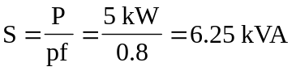

But 